2019 Exhibition Opportunities Media Pack
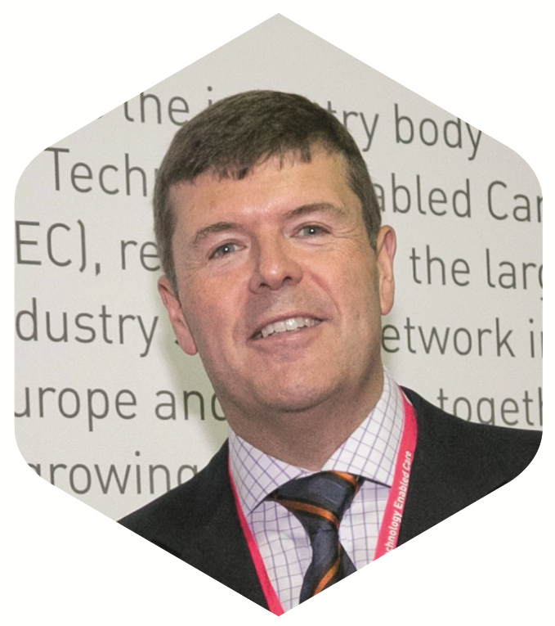
Introduction to the 2019 International Technology Enabled Care Conference
We are delighted to announce that following the huge success of our 2018 conference, the 2019 International Technology Enabled Care Conference will return to the fantastic International Convention Centre (ICC) in central Birmingham, on Tuesday 15th and Wednesday 16th October 2019.
The ICC’s prime location in the heart of Birmingham’s city centre means that it’s easily accessible for attendees, in fact 80% of the UK population can reach Birmingham in 90 minutes. Birmingham’s main train station is the UK’s largest interchange rail station and it also has one of the most accessible international airports in Europe, making it ideal for both one day and two day attendees.
The theme for the 2019 conference is ‘Citizen Powered Communities’, and we are delighted to announce that TSA President and former Minister of State for Care Services, Rt Hon Paul Burstow will chair this year’s event.
Paul’s role as conference chair will include him joining the conference planning committee, where he will support the development of the 2019 programme, helping TSA to build an exciting two day programme packed with industry leaders and influential plenary speakers, specifically targeted to attracting new audiences into conference.
Last year’s conference attracted over 800 attendees. To help support the growth of this year’s conference, TSA have once again approached key influential organisations such as the Academic Health Science Networks to be involved in conference and send key influential figures with up to 300 free tickets per day to encourage increased attendance and wider promotion via their stakeholders including Clinical Commissioning Groups, GP`s and Hospital Trusts.
With a conveniently located venue in place for 2019, we are looking to increase the number of attendees we have each day to more than 900. We have high expectations and believe that year’s conference should be the biggest and the best one yet.
The International Technology Enabled Care Conference will offer a number of great opportunities for organisations to raise brand awareness to the key influential players in the Technology Enabled Care Sector.

The Venue
  The International Convention Centre (ICC)  Broad Street, Birmingham B1 2EA | 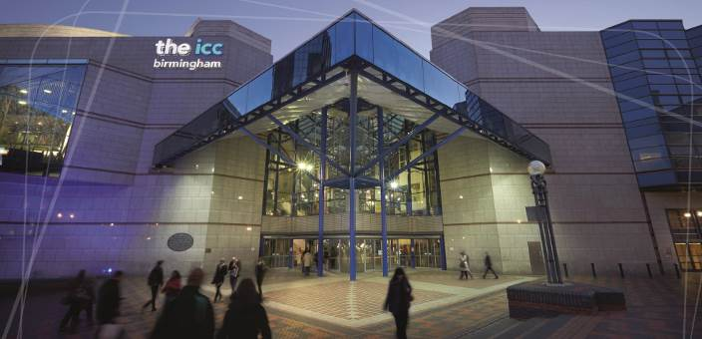
The ICC’s prime location in the heart of Birmingham’s city centre means that it’s easily accessible for attendees, in fact 80% of the UK population can reach Birmingham in 90 minutes. Birmingham’s main train station is the UK’s largest interchange rail station and it also has one of the most accessible international airports in Europe, making it ideal for both one day and two day attendees.
The ICC has ten halls and ten executive meeting rooms, with dedicated registration and foyer areas, provide some of the UK's largest and most flexible conference facilities and spaces under one roof.
With a tiered auditorium that will seat over 1,250 delegates and an exhibition hall offering over 3000 square metres of tailored space, the ICC is a professional conference centre of the highest order.
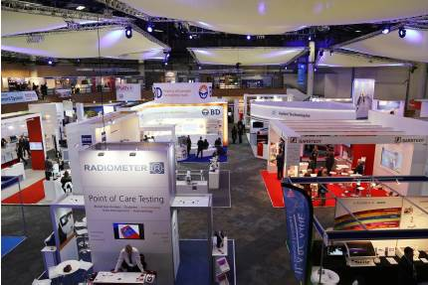
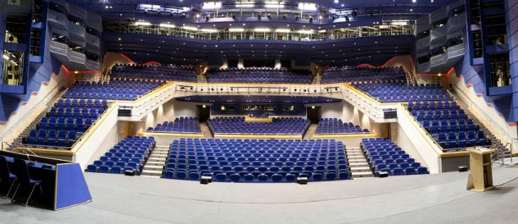
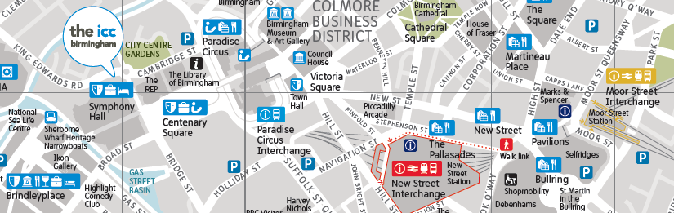

Exhibition Opportunities
The ICC offers over 3000 m2 of exhibition and networking spaces, located centrally next to the main plenary lecture theatre and delegate registration areas. This increased space has allowed us to introduce a number of new interactive zones within the exhibition hall that are designed to increase engagement, encourage partnership working and collaborations.
The International Technology Enabled Care Conference will offer you an unmissable opportunity to showcase your products and services to key industry players and will ensure you make your mark on the TEC market.
Reasons to Exhibit
- The profile for conference makes it the key event for developers and providers of equipment, services and specialist consultancies across the technology enabled care space.
- Raise awareness of your brand to health, housing, home care and social care providers and professionals
- Meet and network with the Technology Enabled Care sector’s leading industry figures
- Conduct direct sales and develop lucrative sales leads that you wouldn’t find anywhere else
- Engage with key decision makers
- Obtain a competitive edge on your competitors
- Don’t miss the opportunity to exhibit at the biggest event for the Technology Enabled Care industry.
Exhibition Stand Rates
Stand Type | Stand Size |  | TSA Member | Non TSA Member
Platinum | 5m x 4 m (20 m2) |  | £7,000.00 | £7,700.00
Gold | 4m x 3m (12m2) |  | £4,800.00 | £5,280.00
Silver | 3m x 2m (6m2) |  | £3,000.00 | £3,300.00
Start-up Innovation stands* | 2m x 1m (2m2) |  | £550.00 | £650.00
Exhibition Floor Plan
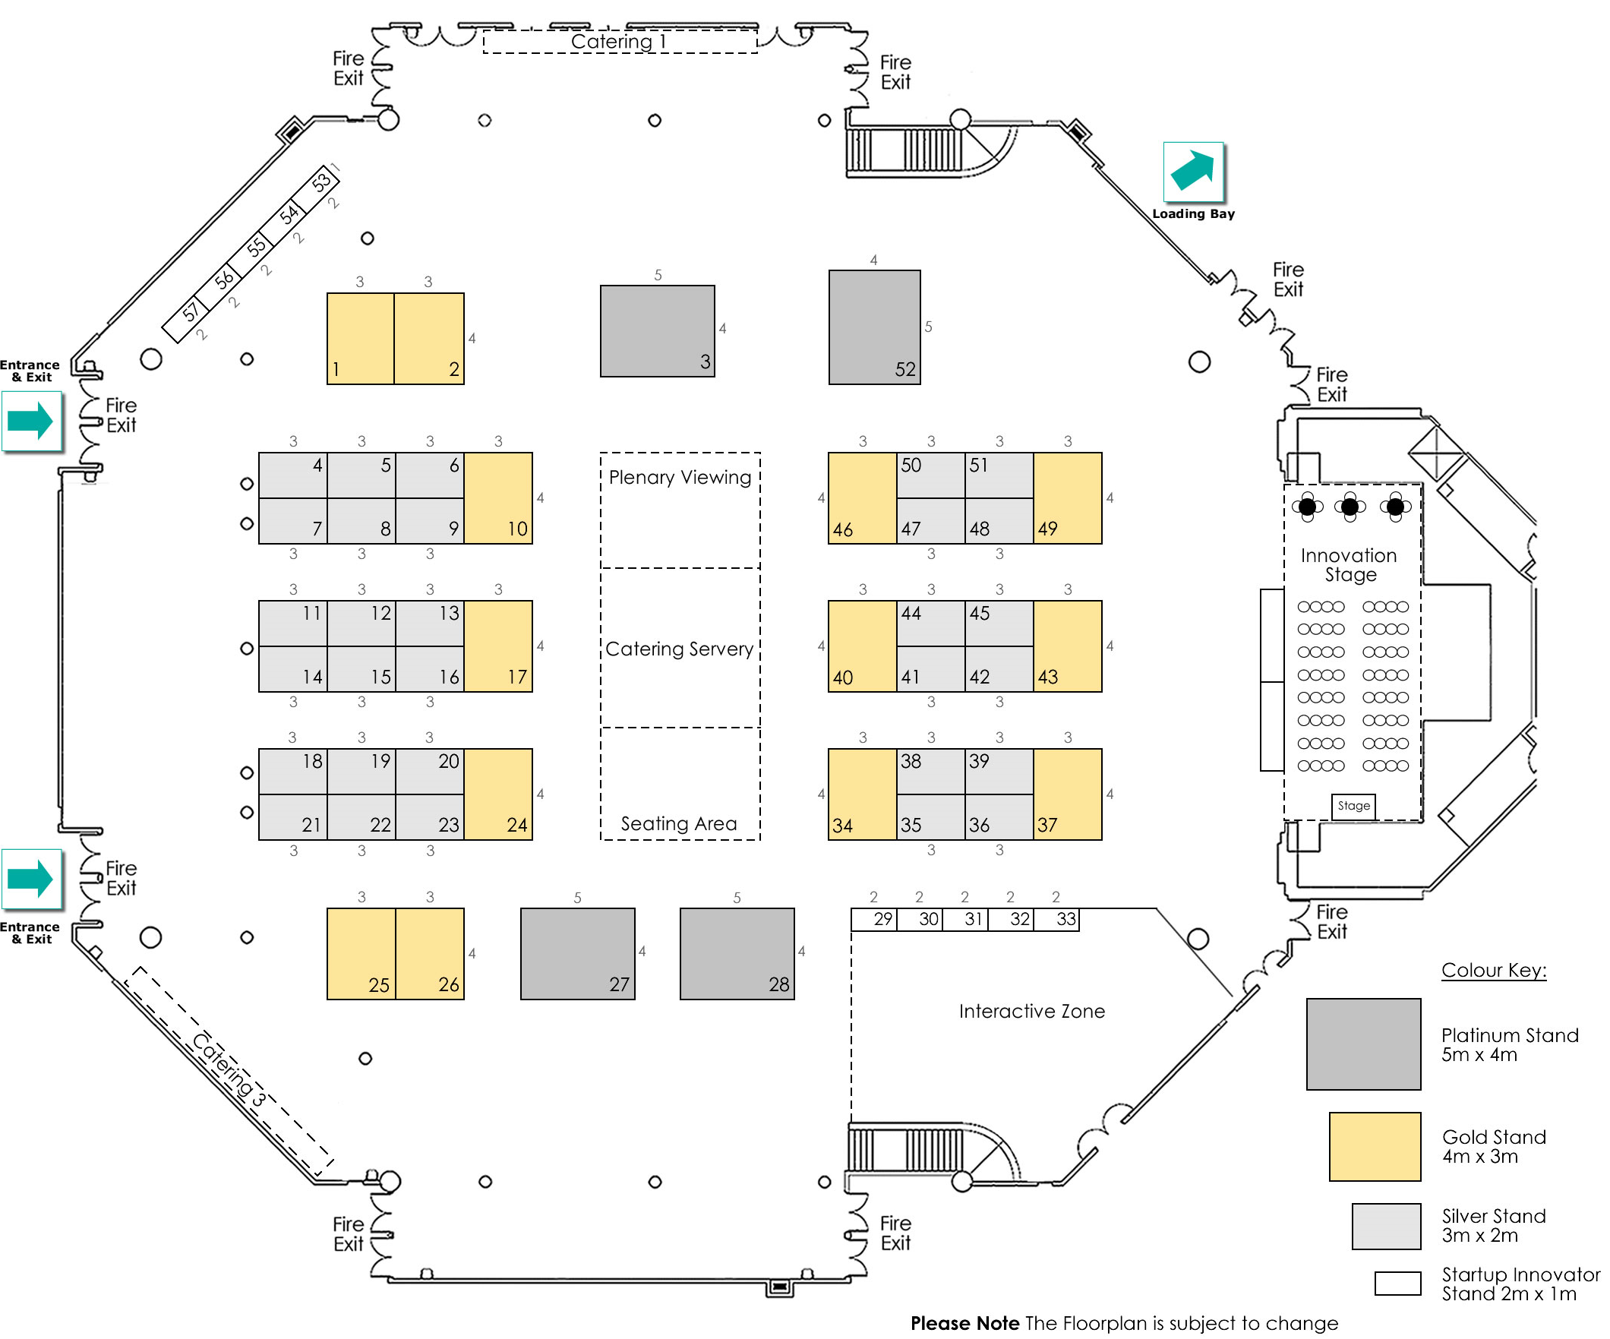
What’s Included
Platinum, Gold and Silver stands will receive:  - Shell scheme (if required), including name boards to open sides  - A clothed 6ft Trestle Table and 2 chairs (if required)  - Two passes for both days of conference for exhibition stand personnel  - Two free one day customer passes to be used on either day of conference  - A single 500 watt socket and lighting  - Wi-Fi internet access |  | *To book a Start-up Innovation Stand your organisation must have less than 10 employees & a turnover under £1 million.  Start-up Innovation stands will receive  - Shell scheme, including name boards to open sides  - A poseur table and single stool  - One pass for both days of conference for exhibition stand personnel  - A single 500 watt socket and lighting  - Wi-Fi internet access

