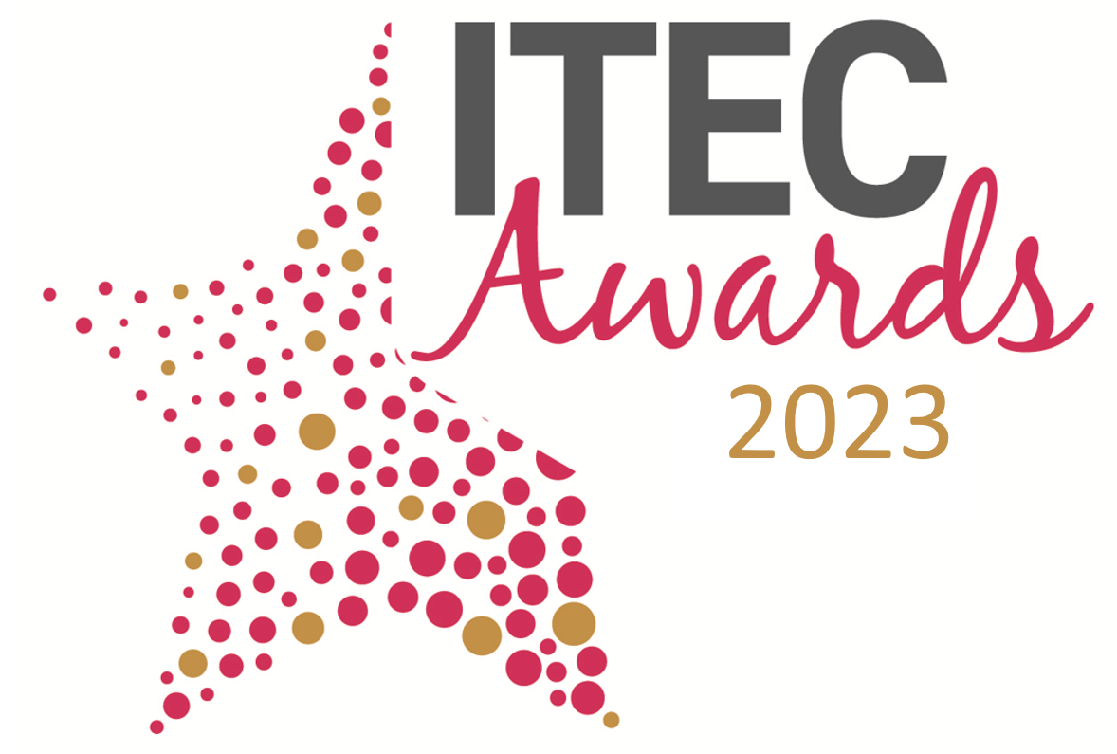
International Technology Enabled Care Awards 2023
Entry Form - TEC Innovation Award
Please complete all aspects of this form and return it via email to: awards@TSA-Voice.org.uk
Full Name:
Job title:
Organisation:
Postal Address:
 | Postcode:
Email:
Contact Telephone Number:
Date of Submission:
Please confirm you are entering a submission for the TEC Innovation Award: |  | □
To help us promote your submission should you be shortlisted please provide the following:
Company Twitter Handle:
LinkedIn Address:
Facebook page:

Awards Category
Please see below further information on the award category and details of the submission criteria that is required. For your submission please also demonstrate how your entry supports TSA’s vision of:
People’s everyday lives enriched, enhanced and enabled by technology-enabled care

- TEC INNOVATION AWARD
Has your organisation developed a recent innovative TEC product or service? We are looking for examples of TEC products or services which have proceeded through early trials or pilots or have been recently integrated and implemented. Products/Services may be standalone or integrated into innovative service delivery. Effective examples of digital innovation would be co-produced with users, carers and practitioners and show early evidence of improving individual health and care outcomes.
Include in your submission:
- What has your innovation made possible, which was impossible before?
Think about: RELEVANCE, COMPLETENESS, INNOVATION
- What impact has your innovation had on individuals and organisations? Please provide examples, evidence and case studies to support your application.
Think about: USE OF TECHNOLOGY, WINNING HEARTS AND MINDS, IMPROVING DAILY PRACTICE
- What does your innovation and the evidence collected mean for the future of the wider TECS community and its service users?
Think about: IMPACT, LEGACY, EVALUATION AND EVIDENCE

Please send your completed entry to reach the awards administrator no later than is 5pm on Friday 17 February 2023. Email your completed entry form, together with your submission and any supplementary evidence to: awards@TSA-Voice.org.uk

Guidelines for completing your entry
- You must complete this entry form, in full, and return it with your completed submission.
- Please return your submission as a word document and not in any other format.
- You can apply for more than one award category, but you must complete an entry form for each category you enter and send them as two separate submissions.
- Entry submissions should be a maximum of 1000 words, in total. Entry submissions over 1000 words may not be considered by the judges. On top of your 1000-word entry you are asked to provide a 100-word synopsis of your submission.
- It is important that your entry is clear, concise and shows how you meet the award category statements and also demonstrates how your entry supports TSAs vision that People’s Everyday Lives are Enriched, Enhanced and Enabled by Technology Enabled Care. Submissions will be judged against these specific category statements.
- Only relevant supplementary information will be considered, which is in context with the submission. No marketing material should be used.
- Entrants may mark certain sensitive parts of their entry ‘not for publication’ such as exact budget figures etc.
- The judging panel’s decision is final.
- All shortlisted entrants must be present at the gala dinner on the evening of the 27 March at the ICC, Birmingham
- We would request all winners to join us on day 2 (28 March) of the conference and join a session on the innovation stage, alongside the other award category winners, to be interviewed about your entry

Please Note: Descriptions of submissions (other than commercially sensitive data previously notified) from winners and runner-ups may be used in publicity linked to the awards.

By returning this form, organisations/individuals agree to all the above the rules and guidelines outlined above.

Please add your submission below:
Please detail your submission below answering the relevant statements for your award category by referencing the guidelines provided (there is no specific word count per statement, please ensure the total word count for the submission is no more than 1000 words).

1. | What has your innovation made possible, which was impossible before?  Think about: RELEVANCE, COMPLETENESS, INNOVATION
2. | What impact has your innovation had on individuals and organisations? Please provide examples, evidence and case studies to support your application.  Think about: USE OF TECHNOLOGY, WINNING HEARTS AND MINDS, IMPROVING DAILY PRACTICE
3. | What does your innovation and the evidence collected mean for the future of the wider TECS community and its service users?  Think about: IMPACT, LEGACY, EVALUATION AND EVIDENCE
In addition to your 1000-word submission please provide below a short 100-word synopsis of your submission.

If you are shortlisted, we will use the synopsis in the awards guidebook and in marketing material during and after the event has taken place.

100-word synopsis

Supplementary Evidence:
You are able to submit additional supplementary evidence to support your submission.
Supplementary evidence must be no longer than 2 pages of A4
Please submit your supplementary evidence along with your submission in order to uphold your entry claim.
Supplementary evidence may include: Case studies, original research, survey results, testimonials and infographics (in total this must be no more than 2 pages of A4)

