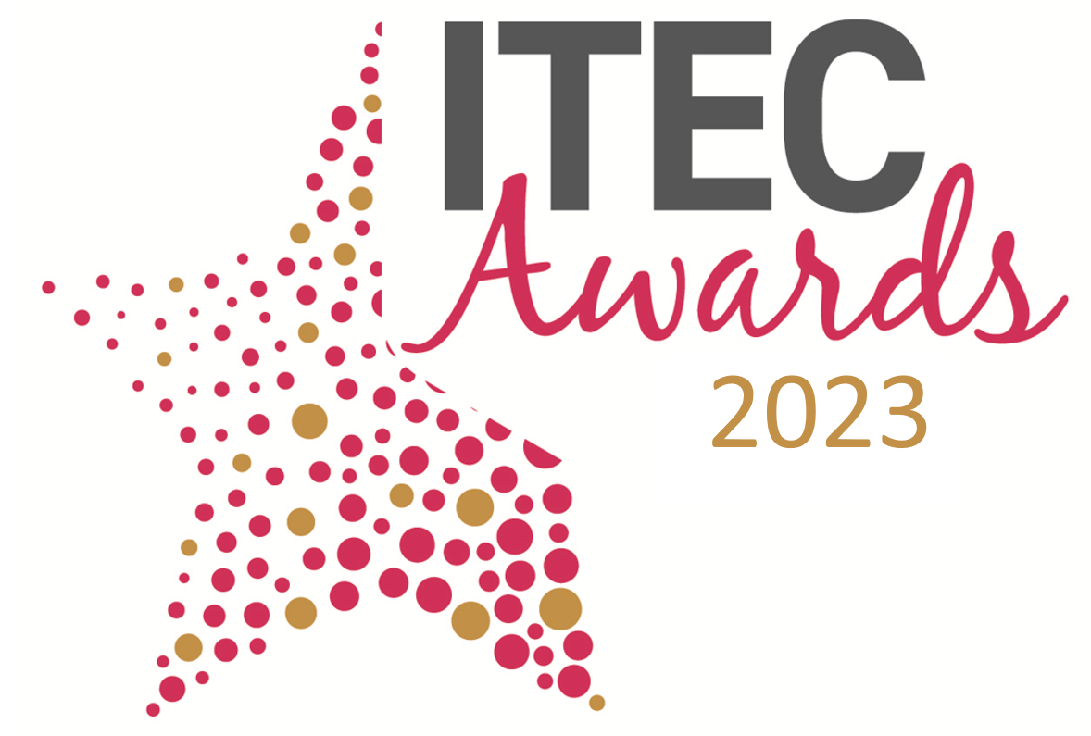
The TSA ITEC Awards
TSA are delighted to once again present the International Technology Enabled Care (ITEC) Awards to be held at the prestigious Gala Dinner at this year’s ITEC conference on the evening of the 27 March 2023 at the ICC Birmingham.
What are the TSA ITEC Awards?
The awards forms part of the experience of ITEC conference which is the industry recognised event for Technology Enabled Care in the UK taking place on 27 - 28 March 2023 at the ICC Birmingham.

TEC can have a huge impact on people's lives by providing emergency support, helping people manage their health and wellbeing, remain independent for longer within their communities and living longer and more enriched lives.
The TSA ITEC Awards are open to any organisation or individual working in Technology Enabled Care in the UK and overseas and they recognise excellence and outstanding achievements in TEC provision both service, product and a combined approach.
The ITEC Awards act as a hallmark of quality for your organisation and will attract recognition from the TEC community and wider stakeholders of the difference the winners and entrants make to the TEC industry and the millions of people it supports.
The 5 categories for the 2023 ITEC Awards are:
- TEC Innovation Award
- Workforce Development in TEC Award
- Partnerships in TEC Award
- Leadership Award
- Transformation Award

Why enter the ITEC Awards?
Shortlisted entrants will:
- Have their entry featured on the night of the awards ceremony at the TSA International Technology Enabled Care Conference 2023
- A synopsis entry in the Awards booklet plus featured on the ITEC Conference website
- Feature in the pre-show ITEC Conference mailer campaign, distributed to thousands of industry stakeholders
- Benefit from pre-award publicity on the TSA website and social channels

Additionally, award winners will:

- Grab the headlines at the prestigious ITEC 2023 Gala Dinner
- Have the opportunity to join a session on the Innovation Stage on day 2 of the conference, alongside the other award category winners, to be interviewed about your entry
- Have use of the ITEC 2023 Winner logo for one-year following the Awards
- Benefit from extensive post-award publicity on the TSA website and social channels
Awards Categories
Please see below further information on each award category and details of the submission criteria that is required.

- TEC INNOVATION AWARD
Has your organisation developed a recent innovative TEC product or service? We are looking for examples of TEC products or services which have proceeded through early trials or pilots or have been recently integrated and implemented. Products/Services may be standalone or integrated into innovative service delivery. Effective examples of digital innovation would be co-produced with users, carers and practitioners and show early evidence of improving individual health and care outcomes.
Include in your submission:
- What has your innovation made possible, which was impossible before?
Think about: RELEVANCE, COMPLETENESS, INNOVATION
- What impact has your innovation had on individuals and organisations? Please provide examples, evidence and case studies to support your application.
Think about: USE OF TECHNOLOGY, WINNING HEARTS AND MINDS, IMPROVING DAILY PRACTICE
- What does your innovation and the evidence collected mean for the future of the wider TECS community and its service users?
Think about: IMPACT, LEGACY, EVALUATION AND EVIDENCE

- WORKFORCE DEVELOPMENT IN TEC AWARD
Have you recently achieved a level of transformation within your organisation through a workforce approach? Are you able to demonstrate that people and empowering staff is central to your operations, your values and culture? Please provide evidence to support your application.
Include in your submission:
- How has the organisation demonstrated its commitment to ongoing workforce development?
Think about: TRAINING AND PERSONAL DEVELOPMENT, ALTERNATIVE WAYS OF WORKING, STRENGTHENING TRUST AND CONFIDENCE
- How has the organisation empowered its workforce to think and behave differently?
Think about: EMPOWERMENT, TEAM ETHICS AND STANDARDS, INTERNAL BUY-IN,
- How has the organisation embedded a culture change across the organisation for a improved and happier workforce?
Think about: LEADERSHIP, COMMUNICATION, COLLABORATIVE WORKING

- PARTNERSHIPS IN TEC AWARD
Partnerships is the foundation of TSA’s strategic activity, and we are looking for exemplars within the sector. Have you been central to the creation of an innovative partnership that has improved outcomes/systems but may also have accelerated the agenda, profile and uptake of technology enabled care amongst stakeholders.
Include in your submission:
- How have you engaged and collaborated with a range of stakeholders and demonstrated clear benefits and outcomes of partnership working?
Think about: BUSINESS CASE, RELATIONSHIPS, SCALEABILITY
- To what extent has your partnership increased trust, understanding and confidence amongst commissioners, professionals, and service users?
Think about: ENHANCEMENT OF TEC AGENDA, INCREASED CHOICE AND CONTROL, IMPROVEMENT OF CARE
- What outcomes have been achieved by the partnership and what have been the impacts on the wider health, housing and social care network and/or communities
Think about: OUTCOMES FOR PEOPLE, BENEFITS REALISATION, INCREASED UPTAKE OF TEC

- LEADERSHIP AWARD
We are looking for an individual leader or team that has demonstrated outstanding TEC leadership skills, vision, and action. Their impactful activity will ultimately have had a focus on the use of digital TEC products and services to improve outcomes for users, families, and carers. These are individuals who involve and empower stakeholders and develop workforce and system-wide strategies. They build on successes and learn from failures, constantly looking to improve quality, impact, and cost-effectiveness.
Include in your submission:
- What does the individual/team do to translate their vision into an active agenda for the ongoing development and transformation of the TEC sector?
Think about: INFLUENCING ACTIVITY, KNOWLEDGE TRANSFER, BEST PRACTICE,
- How does the individual/team effect change from strategy through to implementation?
Think about: STRATEGIC INFLUENCER, LEADERSHIP, RELATIONSHIPS
- How does the individual/team influence people and organisations to think and behave differently?
Think about: DYNAMIC LEADERSHIP, EMPOWERING OTHERS, CHANGE MANAGEMENT,
WORKFORCE DEVELOPMENT

- TRANSFORMATION AWARD
This pivotal Award will celebrate and applaud services that have planned and implemented major transformation across their organisation with a proactive and preventative approach. These examples of transformation are likely to have impacted on the wider network with the objective of accelerating the uptake of TEC and/or streamlining processes for better outcomes.
Include in your submission:
- How have you delivered major transformation?
Think about: PROCESSES, TRAINING, USE OF TECHNOLOGY, INSIGHTS
- What have been the effects of this transformation on people’s lives and how have you measured this?
Think about: MEASURES, OUTCOMES, SATISFACTION, SAVINGS/OUTCOMES FOR THE WIDER COMMUNITY
- What were the major influences on your service transformation? How did they influence this and how did your planning for delivering the transformation reflect these influences?
Think about: EXTERNAL FACTORS, LEARNING FROM OTHERS, POLICY, SERVICE PLANNING, STAKEHOLDER INVOLVEMENT

The entry process
- The deadline for receipt of entries is 5pm on Friday 17 February 2023
- A word count of 1000 words applies to each entry submission
- Do not include general marketing information in support of your submission
- You can apply for more than one award category, but you must complete separate submissions for each category and send them back individually.
- Full guidance can be found on the entry forms
- Shortlisted entrants will be notified during the week commencing 6 March 2023
- The winners will be announced on 27 March 2023 during the Gala Dinner at the International Technology Enabled Care Conference 2023, which will be held at the ICC, Birmingham.

How entries are judged
We have specially selected a panel of judges based on their experience and knowledge of TEC and/or their profile within the care and support sector.

- Entries will be anonymised by TSA’s moderator and any which do not satisfy the rules and conditions will be discounted.
- Entries will then be scored according to the extent to which they answer the main question and satisfy or exceed the categories criteria. Our panel will be looking for entries which demonstrate this clearly, concisely, and verifiably and cover at least one of the points attached to each of the criteria. They will score each entry on merit and will not compare entries with one another until the final selection.
- The moderator will compile the scores and check for fairness. The highest-scoring entries per category will be shortlisted.
- The judging panel will choose the winners from the shortlisted entries.

Top tips
- Allow plenty of time for several people to review and contribute to your entry. A variety of perspectives could help you demonstrate the impact of your work.

- Make sure you understand the key questions. If you are unsure, please contact TSA at
awards@tsa-voice.org.uk

- Bear in mind what the judges are looking for:
  - Answering your category statements is essential, and covering the points attached to each one will help you create a thorough and well-structured entry.
  - The judges will mark your entries against the category statements, failure to address one of the points will lead to a lower score being obtained, or even an entry being dismissed by the judges
  - Keep your entry focused - the judges want clarity and will ignore anything irrelevant.
  - Avoid jargon and acronyms - remember the judges are from a variety of backgrounds and might not know everything about your business.

- Back up your claims with evidence and evaluation of outcomes.
- Submitting marketing and promotional copy within the entry will be discounted.

- Present your entry carefully – double-spacing your lines and checking the structure and grammar of your entry will help the judges make sense of it easily. You are welcome to include images and infographics to support your entry
- Enjoy the ride! Completing an awards process can help you recognise what you’re doing well or even notice what might be missing or underdeveloped in your everyday work – it’s a useful vehicle to focus on what you offer.

Good luck!

The TSA Team

