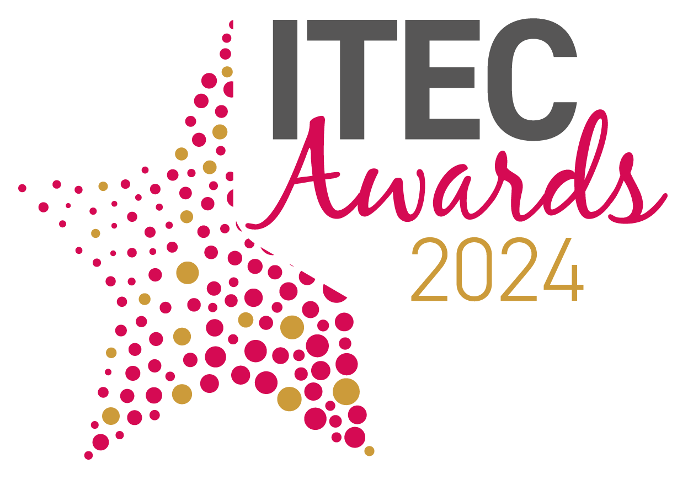
International Technology Enabled Care Awards 2024
Entry Form - Partnerships
Please complete all aspects of this form and return it via email to: awards@TSA-Voice.org.uk
Full Name:
Job title:
Organisation:
Postal Address:
 | Postcode:
Email:
Contact Telephone Number:
Date of Submission:
Please confirm you are entering a submission for the Partnerships Award |  | □
To help us promote your submission should you be shortlisted please provide the following:
Company Twitter Handle:
LinkedIn Address:
Facebook page:

Award Category
Please see below further information on the award category and details of the submission criteria that is required. For your submission please also demonstrate how your entry supports TSA’s vision of:
People’s everyday lives enriched, enhanced and enabled by technology-enabled care

- PARTNERSHIPS
Partnerships is the foundation of TSA’s strategic activity, and we are looking for exemplars within the sector. Have you been central to the creation of an innovative partnership that has improved outcomes/systems but may also have accelerated the agenda, profile and uptake of technology enabled care amongst stakeholders.
Include in your submission:
- Why and how have you engaged and collaborated with a range of stakeholders and demonstrated clear benefits and outcomes of partnership working?
Think about: BUSINESS CASE, RELATIONSHIPS, OUTCOMES FOR PEOPLE
- To what extent has your partnership increased trust, understanding and confidence amongst commissioners, professionals, and service users?
Think about: ENHANCEMENT OF TEC AGENDA, INCREASED CHOICE AND CONTROL, IMPROVEMENT OF CARE
- What outcomes have been achieved by the partnership and what have been the impacts on the wider health, housing and social care network and/or communities?
Think about: BENEFITS REALISATION, INCREASED UPTAKE OF TEC, SCALABILITY

Please send your completed entry to reach the awards administrator no later than 5pm on Friday 9 February 2024. Email your completed entry form, together with your submission and any supplementary evidence to: awards@TSA-Voice.org.uk

Guidelines for completing your entry
- You must complete this entry form, in full, and return it with your completed submission.
- Please return your submission as a word document and not in any other format.
- You can apply for more than one award category, but you must complete an entry form for each category you enter and send them as two separate submissions.
- Entry submissions should be a maximum of 1000 words, in total. Entry submissions over 1000 words may not be considered by the judges. On top of your 1000-word entry you are asked to provide a 100-word synopsis of your submission.
- It is important that your entry is clear, concise and shows how you meet the award category statements and also demonstrates how your entry supports TSAs vision that People’s Everyday Lives are Enriched, Enhanced and Enabled by Technology Enabled Care. Submissions will be judged against these specific category statements.
- Only relevant supplementary information will be considered, which is in context with the submission. No marketing material should be used.
- Entrants may mark certain sensitive parts of their entry ‘not for publication’ such as exact budget figures etc.
- The judging panel’s decision is final.
- All shortlisted entrants must be present at the gala dinner on the evening of the 18 March 2024 at the ICC, Birmingham
- We would request all winners join us on day 2 (19 March) of the conference to be interviewed about your entry

Please Note: Descriptions of submissions (other than commercially sensitive data previously notified) from winners and runner-ups may be used in publicity linked to the awards.

By returning this form, organisations/individuals agree to all the above the rules and guidelines outlined above.

Please add your submission below:
Please detail your submission below answering the relevant statements for your award category by referencing the guidelines provided (there is no specific word count per statement, please ensure the total word count for the submission is no more than 1000 words).

1. | Why and how have you engaged and collaborated with a range of stakeholders and demonstrated clear benefits and outcomes of partnership working?  Think about: BUSINESS CASE, RELATIONSHIPS, OUTCOMES FOR PEOPLE
2. | To what extent has your partnership increased trust, understanding and confidence amongst commissioners, professionals, and service users?  Think about: ENHANCEMENT OF TEC AGENDA, INCREASED CHOICE AND CONTROL, IMPROVEMENT OF CARE
3. | What outcomes have been achieved by the partnership and what have been the impacts on the wider health, housing and social care network and/or communities?  Think about: BENEFITS REALISATION, INCREASED UPTAKE OF TEC, SCALABILITY
Supplementary Evidence:
You are able to submit additional supplementary evidence to support your submission.
Supplementary evidence must be no longer than 2 pages of A4
Please submit your supplementary evidence along with your submission in order to uphold your entry claim.
Supplementary evidence may include: Case studies, original research, survey results, testimonials and infographics (in total this must be no more than 2 pages of A4)
Please provide the following information, which will be used should your submission be shortlisted as a finalist or a winner in your category.

Please provide below a short 100-word synopsis of your submission.
Should you be shortlisted, we will use this synopsis in the awards guidebook and in marketing material during and after the event has taken place.

100-word synopsis

Company Logo: |  | Please send us, along with your submission, your company logo (as a high resolution PNG file) that we will use on the evening.  Should your submission relate to multiple organisations, please send in all logos along with your submissions
Award Engraving
Should your submission be the category winner, please detail below the company name/s that should be engraved on to the award

